Experiment No – 5

Title / Aim :- Use string functions and regex for email validation, data extraction, and text analysis.
Software/Tools Required :-
- Visual Studio Code (VS Code)
- Google Chrome / Any Web Browser
- HTML
- JavaScript

CODE :-
Index.html
<!DOCTYPE html>
<html lang="en">
<head>
<meta charset="UTF-8">
<meta name="viewport" content="width=device-width, initial-scale=1.0">
<title>Resume Text Analyzer</title>
<link rel="stylesheet" href="style.css">
</head>
<body>
<div class="container">

<header>
<div class="icon">📄</div>
<h1>Resume Text Analyzer</h1>
<p>Analyze resume content using JavaScript String Functions & Regex</p>
</header>

<!-- Input -->
<section class="card">

<h2>📝 Paste Your Resume</h2>

<textarea id="resumeText"
placeholder="Paste your resume text here...

Example:
Shivangi Kushwaha
Email: shivangi@gmail.com
Phone: 9876543210
Skills: JavaScript, Python, HTML, CSS
Education: B.Tech Computer Science
Experience: Software Development Intern">
</textarea>

<button class="analyze-btn" onclick="analyzeResume()">
🔍 Analyze Resume
</button>

</section>

<!-- String Functions -->
<section class="card">

<h2>🔤 String Analysis</h2>

<div class="grid">

<div class="box">
<h3>Length</h3>
<p id="length">-</p>
</div>

<div class="box">
<h3>Words</h3>
<p id="wordCount">-</p>
</div>

<div class="box">
<h3>Characters</h3>
<p id="characters">-</p>
</div>

<div class="box">
<h3>Uppercase</h3>
<p id="uppercase">-</p>
</div>

<div class="box">
<h3>Lowercase</h3>
<p id="lowercase">-</p>
</div>

<div class="box">
<h3>Trimmed Text</h3>
<p id="trimmed">-</p>
</div>

</div>

</section>

<!-- Email Extraction -->
<section class="card">

<h2>📧 Extracted Email IDs</h2>

<div id="emails" class="email-result">
No email IDs found.
</div>

</section>

<!-- Skill Search -->
<section class="card">

<h2>💻 Check Resume Skill</h2>

<div class="search-box">

<input
type="text"
id="skill"
placeholder="Enter skill e.g. Python"
>

<button onclick="checkSkill()">
Check Skill
</button>

</div>

<p id="skillResult"></p>

</section>
<!-- Replace -->
<section class="card">

<h2>✏️ Replace Text</h2>

<div class="search-box">

<input
type="text"
id="oldText"
placeholder="Text to replace"
>

<input
type="text"
id="newText"
placeholder="New text"
>

<button onclick="replaceText()">
Replace
</button>

</div>

<p id="replaceResult"></p>

</section>

</div>
<script src="script.js"></script>
</body>
</html>

Style.css
* {
box-sizing: border-box;
margin: 0;
padding: 0;
font-family: Arial, sans-serif;
}
body {
background: #91c0f0;
color: #1e293b;
padding: 30px;
}
.container {
max-width: 1000px;
margin: auto;
}
/* Header */
header {
background: #334155;
color: white;
text-align: center;
padding: 35px;
border-radius: 18px;
margin-bottom: 25px;
}
.icon {
font-size: 45px;
}
header h1 {
margin: 10px 0;
font-size: 32px;
}
header p {
color: #cbd5e1;
}
/* Cards */
.card {
background: white;
padding: 25px;
margin-bottom: 20px;
border-radius: 15px;
box-shadow: 0 4px 12px rgba(0, 0, 0, 0.08);
}
.card h2 {
margin-bottom: 20px;
color: #334155;
}
/* Resume Input */
textarea {
width: 100%;
height: 220px;
padding: 15px;
border: 2px solid #cbd5e1;
border-radius: 10px;
resize: vertical;
font-size: 15px;
outline: none;
}
textarea:focus {
border-color: #334155;
}
/* Buttons */
button {
padding: 11px 18px;
border: none;
border-radius: 7px;
background: #334155;
color: white;
cursor: pointer;
font-size: 15px;
}
button:hover {
background: #1e293b;
}
.analyze-btn {
width: 100%;
margin-top: 15px;
padding: 14px;
font-size: 17px;
font-weight: bold;
}
/* Analysis */
.grid {
display: grid;
grid-template-columns: repeat(3, 1fr);
gap: 15px;
}
.box {
background: #f8fafc;
border-left: 4px solid #334155;
padding: 18px;
border-radius: 8px;
}
.box h3 {
font-size: 15px;
margin-bottom: 8px;
}
.box p {
color: #475569;
word-break: break-word;
}
/* Emails */
.email-result {
background: #f8fafc;
padding: 15px;
border-radius: 8px;
}
.email {
display: block;
background: #e2e8f0;
padding: 10px;
margin: 7px 0;
border-radius: 6px;
color: #1e293b;
font-weight: bold;
}
/* Search */
.search-box {
display: flex;
gap: 10px;
}
.search-box input {
flex: 1;
padding: 11px;
border: 1px solid #cbd5e1;
border-radius: 7px;
font-size: 15px;
}
#skillResult,
#replaceResult {
margin-top: 15px;
font-weight: bold;
}
/* Mobile */
@media (max-width: 700px) {

.grid {
grid-template-columns: 1fr 1fr;
}

.search-box {
flex-direction: column;
}
}
@media (max-width: 450px) {

.grid {
grid-template-columns: 1fr;
}
}

Script.js
// Analyze Resume
function analyzeResume() {
const resume = document.getElementById("resumeText").value;
// trim()
const trimmed = resume.trim();
// length
const length = trimmed.length;
// toUpperCase()
const upper = trimmed.toUpperCase();
// toLowerCase()
const lower = trimmed.toLowerCase();
// split()
const words = trimmed
.split(/\s+/)
.filter(word => word.length > 0);

// REGEX - Extract valid email IDs
const emailRegex =
/[a-zA-Z0-9._%+-]+@[a-zA-Z0-9.-]+\.[a-zA-Z]{2,}/g;

const emails = trimmed.match(emailRegex) || [];
// replace()
const cleanText =
trimmed.replace(/\s+/g, " ");
// Display results
document.getElementById("length").textContent =
length;
document.getElementById("wordCount").textContent =
words.length;
document.getElementById("characters").textContent =
length;
document.getElementById("uppercase").textContent =
upper;
document.getElementById("lowercase").textContent =
lower;
document.getElementById("trimmed").textContent =
cleanText;
// Display Emails
const emailBox =
document.getElementById("emails");
if (emails.length === 0) {
emailBox.textContent =
"No valid email IDs found.";
} else {
emailBox.innerHTML = emails
.map(email =>
`<span class="email">📧 ${email}</span>`
)
.join("");
}
}
// Check Skill using includes()
function checkSkill() {
const resume =
document.getElementById("resumeText").value;
const skill =
document.getElementById("skill").value.trim();
const result =
document.getElementById("skillResult");
if (skill === "") {
result.textContent =
"Please enter a skill.";
result.style.color = "red";
return;
}
// includes()
if (resume.toLowerCase().includes(skill.toLowerCase())) {

result.textContent =
`✓ ${skill} is present in the resume.`;

result.style.color = "green";
} else {
result.textContent =
`✗ ${skill} was not found in the resume.`;

result.style.color = "red";
}
}
// Replace text using replace()
function replaceText() {
const resume =
document.getElementById("resumeText").value;
const oldText =
document.getElementById("oldText").value;
const newText =
document.getElementById("newText").value;
const result =
document.getElementById("replaceResult");
if (oldText === "") {
result.textContent =
"Enter text that you want to replace.";
return;
}
const updatedText =
resume.replace(oldText, newText);

result.textContent =
updatedText;
}

OUTPUT:-
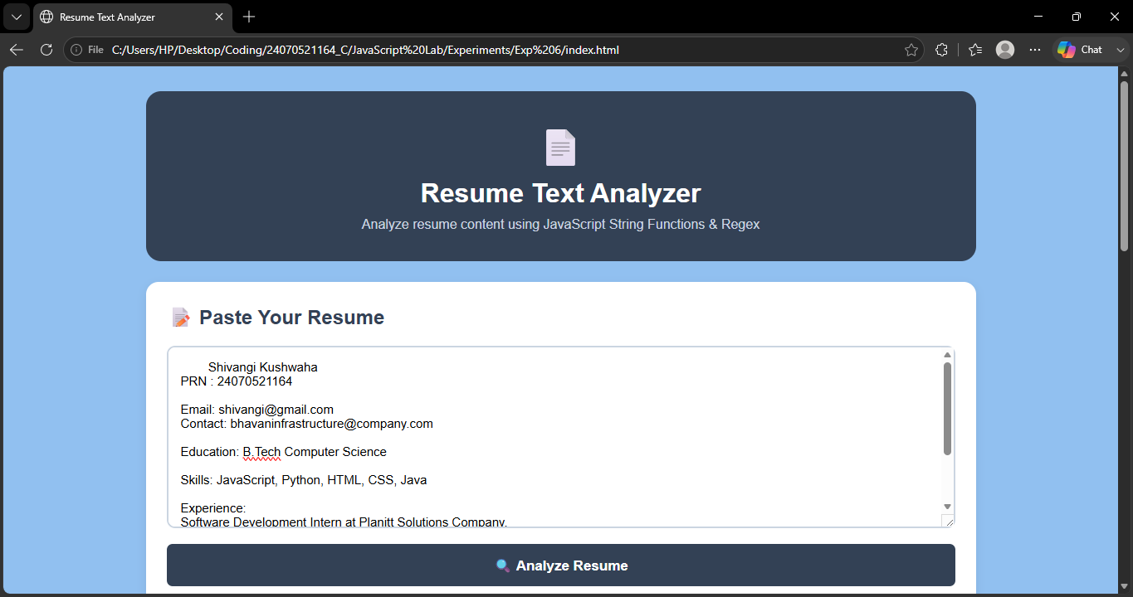

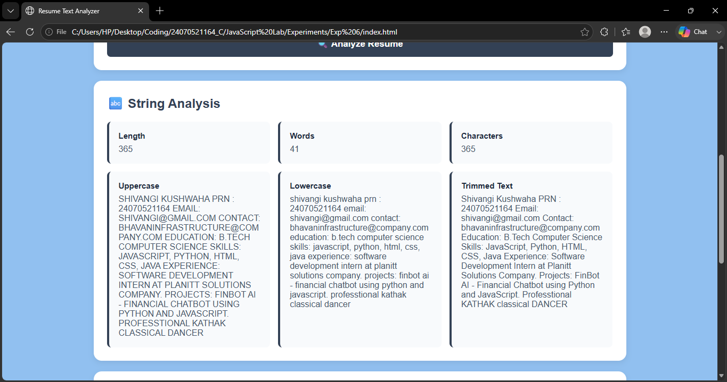
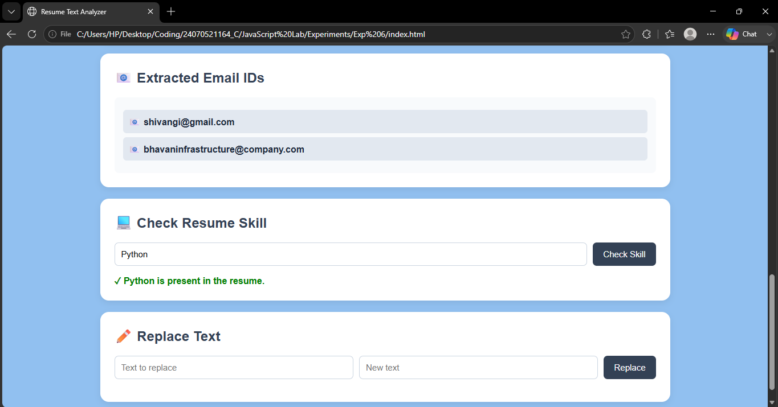

Result / Conclusion :-
The Resume Text Analyzer was successfully developed using HTML, CSS, and JavaScript. It performs various string operations and provides useful information such as character count, word count, and text transformations. The Regex pattern successfully extracts valid email IDs from the resume. The optional skill-search feature also checks whether a particular word or skill is present in the resume. Thus, the experiment provides practical understanding of JavaScript string manipulation, Regular Expressions, data extraction, and text analysis.

